* **-webkit-mask蒙板**

**原理同PS中蒙板效果相同。FF3.6不支持**

1. **-webkit-mask-box-image**

|  |
| --- |
| <img src="kate.png" style="-webkit-mask-box-image: url(mask.png) 75 stretch;"> |

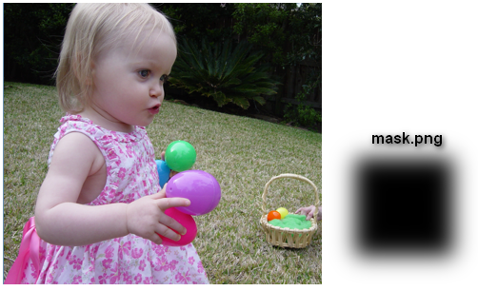

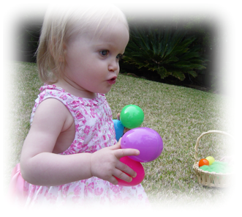

1. **-webkit-mask-image**

**〖线性效果〗**

|  |
| --- |
| <img src="kate.png" style="-webkit-mask-image: -webkit-gradient(linear, left top, left bottom, from(rgba(0,0,0,1)), to(rgba(0,0,0,0)))"> |

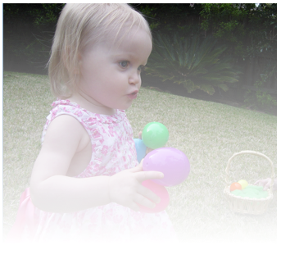

**〖图形效果〗**

|  |
| --- |
| img{-webkit-mask-image: url(images/circle.png);} |

